Data Center Architecture Overview

Md. Abdur Rashid¹

¹PhD Fellow of Bangladesh University of Professionals & Director (Admin & Finance), National Academy for Planning & Development (NAPD), Ministry of Planning, Bangladesh.
Mail: rashid.eee.cse@gmail.com

Abstract
Now is the era of cloud computing where internet based data are handled from remote places. Data is being entered, stored, processed, deposited and backed up all at the central servers located in specific buildings. Data center is a place where all these servers are gathered in compliance with art of technology. We have some limitations regarding knowledge about the architectures of data center. This article reveals some ideas about data center architectures and its components. Specially, this paper gives emphasis on explaining data center tier levels and its applications.
Keywords: Data center, Cloud computing.

Introduction
Information is power. Everyday information of any organization is increasing day by day. World is becoming paperless. So cloud based data processing is going to be more popular. But there are some questions on how the data centers, that we are imagining will be shaped. What elements and standards of data centers will have to be maintained to attain future data demand? It’s worth mulling over on how we will be able to cope up with ongoing technological changes and increasing scalability. Data center classification and its standards, choosing tier levels will help to make sustainable data center. This article will help us to learn about the definition of data center, its classification, standards, modularity, fire system, network design, security, energy used and environmental (ITWatchDogs 2011) issues.This article discusses some of the basic but key considerations for planning and designing data canters, which are dependent on the organization’s business needs, tolerance for failures and availability of budget. Lessons learned from this article will be helpful for researcher, academician, student and organizations dedicated to data center improvement.

Data Center Definition
Data center can be defined as (Rihards Balodis and Inara Opmane ) ‘ A data center is a physical environment facility intended for housing computer systems and associated components. Data centers comprise the above-mentioned computer systems and staff that maintains them. The necessary physical environment facility encompasses power supplies with the possibility to ensure backup power, necessary communication equipment and redundant communication cabling systems, air conditioning, fire suppression and physical security devices for staff entrances.’
Another way data center can be (Papaioannou 2017) defined as ‘Data center infrastructure comprises a large number of servers interconnected by a network.’

History of Data Center
In 1940, once thought that data center means, it holds a lot of computer inside it (https://en.wikipedia.org/wiki/Data_center) ie means a huge big computer rooms. ENIAC, was one of the earliest examples data center. On that time, it was a complex to operate the computers and were needed many cables and other supporting devices with expensive accessories. It requires big floor space to accommodate and needed racks to mount devices. A single mainframe required a great deal of power and cooling was a big issue. During the boom of microcomputer in 1980s, users tried to set at anywhere with little space and no care about operating environment. With the advancement of Information Technology (IT) operations more, user became more concern to maintain IT resources. UNIX operating system became in 1970 after that free Linux operating system came in 1990. By using these types UNIX and Linux computable PC operating system bought the term “Server”. The timesharing operating system rely on the client server model to facilitate sharing unique resources among multiple users. Inexpensive networking items couple with new standards to put IT equipment’s in a hierarchical design that put the servers in a specific room inside the company. The use of the term "data center", as applied to specially designed computer rooms, started to gain popular recognition about this time. It is noted in a article titled History of Data Centre Development (Rihards Balodis) that the term data center itself has been used since the 1990s.

Benefits of Data Center
List of commonly identified benefits that can get from Data Center (DC) are:
- DC Reduce our information technology cost and risks.
- IT manpower requirement should be reduced together with the difficulty in retaining staff with IT skills.
- DC provides high class data facility and state of the art network infrastructure.
- Immediate increase in the network reliability and scalability. As business grows and requires more network resources; DC can easily meet new requirement.
- DC Managed Services provides you with readily available competent IT staffs for operating, monitoring and maintaining system.
- DC Managed Services gives continuous operation, continuous support, security, flexibility 24x7 days.

5 Data Center types and Standard
Data centers can be classified in different aspects depend upon its own characteristics.
Depending on the destination there are four different types (https://www.esds.co.in ) of data centers:
- Corporate data centers
- Web hosting data centers, providing computer infrastructure as a service (IaaS)
- Data centers that provide Turnkey Solutions
- Data centers that use the technology to Web 2.0.
Data center energy expert Jonathan Koomey identified four types of data centers (https://gigaom.com).
- Public cloud providers (Amazon, Google)
- Scientific computing centers (national laboratories)
- Co-location centers (private ‘clouds’ where servers are housed together)
- ‘in-house’ data centers (facilities owned and operated by company using the servers)
To evaluate the quality and reliability, data center standard (https://www.colocationamerica.com) are measured. This standard also indicates the hosting ability of a data center. The Uptime Institute (https://uptimeinstitute.com) is the IT industry’s most trusted and adopted global standard for the proper design, build and operation of data centers – the backbone of the digital economy. Uptime Institute tier standards provide a data center classification also shown in following figure.
Data centers are classified in according to uptime are as follows :
- ‘Tier 1 data center (99.671% minimum uptime)
- Tier 2 data center (99.741% minimum uptime)
- Tier 3 data center (99.982% minimum uptime)
- Tier 4 data center (99.995% minimum uptime)
The higher the tier, the greater the availability. The data center tiers level, levels, requirement and utilization places are (www.colocationamerica.com ; www.netmagicsolutions.com) shown in following table 1:
Tier Level | Requirements | Applications
1 | - Single non-redundant distribution path serving the IT equipment  - Non-redundant capacity components  - Basic site infrastructure with expected availability of 99.671%  - Annual downtime 28.8 hours due to site | - Utilized by small businesses
2 | - Meets or exceeds all Tier 1 requirements  - Redundant site infrastructure capacity components with expected availability of 99.741%  - 99.749% Uptime  - Partial redundancy in power and cooling  - Annual downtime 22 hours due to site | - Utilized by medium businesses
3 | - Meets or exceeds all Tier 2 requirements  - Multiple independent distribution paths serving the IT equipment  - All IT equipment must be dual-powered and fully compatible with the topology of a site's architecture  - Concurrently maintainable site infrastructure with expected availability of 99.982%  - No more than 1.6 hours of downtime per year  - N+1 fault tolerant providing at least 72 hour power outage protection  - Annual downtime 1.6 hours due to site | - Utilized by larger businesses
4 | - Meets or exceeds all Tier 3 requirements  - All cooling equipment is independently dual-powered, including chillers and heating, ventilating and air-conditioning (HVAC) systems  - Fault-tolerant site infrastructure with electrical power storage and distribution facilities with expected availability of 99.995%  - 2N+1 fully redundant infrastructure (the main difference between tier 3 and tier 4 data centers)  - 96 hour power outage protection  - Annual downtime .04 hours due to site | - Utilized by Enterprise corporations
Table 1 Data center Tier level
It is noted from above table that Tier 4 design requires double the infrastructure of a Tier III design. Also noted that both Tier III and Tier 4 data center specifications require IT equipment to have dual power inputs. Following figure 1 shows a typical tier 4 data center.
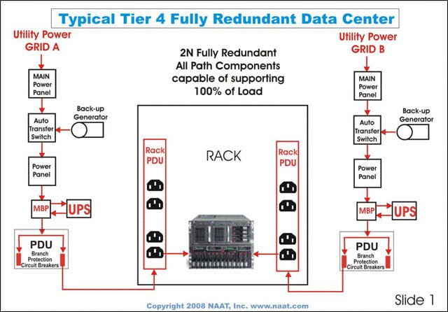
Figure 1 Tier 4 data center

6 Data Center Design Considerations

Technology infrastructure design
Data center design is the process of modeling and designing (Jochim 2017) a data center's IT resources, architectural layout and entire infrastructure. It enables the logical conception of a data center prior to development or implementation in an organization or IT environment.

Site selection
Forecasting next few years, data center location will be chosen. Some commonly identified aspects (Yee Keen Seng) are proximity to available power grids, telecommunications infrastructure, networking services, transportation lines and emergency services. These aspects will help to operate data center smoothly.

Modularity and flexibility

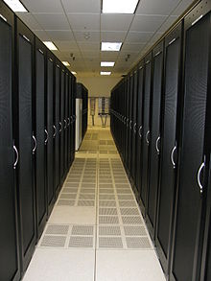
Fig 2 Cabinet aisle in a data center
Modularity (Ajay Ahuja 2015) and flexibility (Ajay Ahuja 2015) are key elements in allowing for a data center to grow and change over time. Data center modules are pre-engineered, standardized building blocks that can be easily configured and moved as needed.

Environmental control
The physical environment of a data center is rigorously controlled. Air conditioning is used to control the temperature and humidity in the data center. Environmental factors (ITWatchDogs 2011) like heat, humidity, airflow, smoke, and electricity can be equally devastating to server room equipment’s.

Electrical power
If national grid fails then a bank of batteries in a large data center, used to provide power until diesel generators can start. Double feeder line can be established from near substation to ensure uninterrupted power supply (Jochim 2017). Typical electrical power supply system is shown following figure.
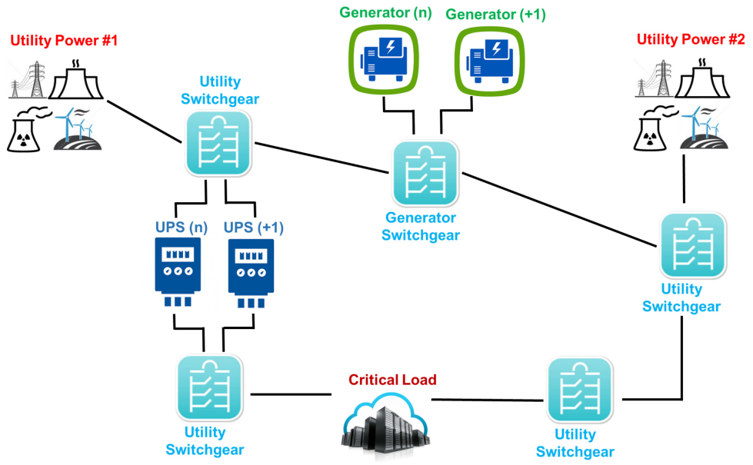
Fig 3 Data Center Electrical Flow

Fire protection
The primary objective is to protect human capital, data center resources and uninterrupted IT services from any instant fire hazard. Detection, alarming, evacuation and extinguishing (Siemens 2015) are the major concern in data center fire protects aspects. Two types of measures are there:
- ‘Active measure
  - Organizational measures and staff-related measures
  - Structural and mechanical measures
  - Technical measures
  - Detection measures
  - Alarm and evacuation measures
  - Intervention measures
- Passive (structural)measure
  - Fire compartmentalization of a building.
  - Use of materials to prevent building collapse.
  - Fire-resistant construction elements to limit spread.
  - Provision of fire-resistant escape routes/exits/staircases/elevators.
  - Selection of materials to reduce fire load.
  - Selection of materials to prevent toxic vapors.
Besides there is fire codes and standards (Himanshu 2014) that can be:
- ‘NFPA 75: Standard for the Protection of Information Technology Equipment’

Security
Physical security also plays a large role with data centers. Physical access to the site is usually restricted to selected personnel. Electronic access control and temporary visiting card can be the solution tools to enter data center. Body checkup must be done before entering data center. 24x7 days security must be ensured by professional security company. All security activities must be supervised by central administration.

Energy efficiency
There is data center energy efficiency metric. This energy efficiency metric (Himanshu 2014). is defined by a formula PUE = Total Facility Power/Total Equipment Power. Where,
PUE= Power Use Effectiveness.
A PUE value (David Cole 2011) of 1 would represent the optimal data center efficiency. In practical, a PUE value of 1 means that all power going into the data center is being used to power IT equipment. Anything above a value of 1 means there is data center overhead required to support the IT load.

Data Center Network
Data center network (DCN) (Bin Wanga 2015) includes data center and provides the connections to the data center, which is described by its network topology, routing/switching equipment, and the protocols it uses.
DCN offers many features to help organize cloud computing for the following reasons (Bin Wanga 2015):
  - ‘DCN permits the connection of thousands of data center servers in an efficient way, so that cloud computing could simply expand its service by following the DCN topology.
  - DCN offers traffic reliability and efficiency to massive machine-to-machine communications in which activities from cloud computing emerge as the workloads distributed on data center servers.
  - DCN supports various virtualization techniques that help DCN to create Virtual Machine (VM), virtual network, and virtual function. DCN should possess the scalability to provide isolation and migration to massive numbers of virtual instances.’

Data Centre Current Scenario in Bangladesh
At present, 3 tier National Data Centre (NDC) is running under the ICT division. It’s storage capacity is 1 petabyte (One petabyte is equivalent to 10 lakh gigabytes.). The storage capacity is already full. This NDC is going to be upgraded to tier 4 and will be located in the Bangabandhu Hi-Tech City at Kaliakoir in Gazipur (The Daily Star 2018). Chinese vendor ZTE Corporation is the developer of this project. Uptime Institute (Data Center certification provider in USA), the global authority on data center best practices, will carry out a technical audit of Bangladesh 4 tier NDC. This will be the first Tier 4 national data center, comprising the most advanced technology in use around the world as part of the government's move to boost the country's data storage capacity. Government is trying to augment the capacity to up to 50 petabytes to store the huge data the country is producing now to achieve Digital Bangladesh. Tier 4 data center will have 0.8 hours of interruption a year, which is half of the disruption faced by a Tier 3 center.

7.1 NDC Service Packages
Following services are provided by Bangladesh NDC (BCC web portal 2019). Services are:
- Hosting Services
  - Web Hosting Service (Linux)
  - Web Hosting Service (Microsoft)
  - Application Hosting Services (Linux)
  - Application Hosting Services (Microsoft)
- Computing Services
  - VPS
  - Load Balancer
- Email Service
  - Zimbra Email
- Database Service (Shared)
  - Oracle
  - MySQL
  - Microsoft SQL Server
- Storage Services
- Collocation Services
  - Rack Unit Allocation Services
- Network Services

Data Centre Current International Scenario
A global survey report on Data Centers have been published (Uptime Institute 2018) by Data Center certificate provider Uptime Institute. Some key challenges and complexities facing data center managers globally were findings of that survey. Key findings are stated bellow. “
- Efficient but more complex: PUE across the industry has improved, signaling an improvement in data center efficiency. Today, operators are grappling with new challenges, including the business case and cost of hybrid IT approaches.
- Edge computing is coming: Operators are expecting to deploy significant new edge computing capacity, which will add a layer of operational and management complexity.
- Rack density issues are growing: The highest rack densities reported at enterprise and service provider data centers suggests that many operators face cooling challenges.
- DCIM is now mainstream: A small majority of data centers now have some type of DCIM, and typically their implementation has been successful (contrary to widespread industry reports).
- Many data centers are unprepared for, or their managers are not expecting to be affected, by climate change: Despite being vulnerable to increased temperatures, water shortages, and extreme and sometimes disastrous weather events, most data center operators have determined that they either won’t be impacted or are ignoring the problem.
- Data center skill shortages will intensify: In this aging and overwhelming male sector, most operators are struggling with staffing issues. Yet most do not believe a lack of diversity in their ranks is an issue to be concerned about. “

9 Conclusion
Though data center investment is high at initial period but actually it is not so costly for long term perspective. A data centers has its huge impact in economic development and organizational efficiency improvement. Given the large investments in data centers, organizations should plan their data centers properly consider their available budget and tolerance for failures and disruptions. The organization must anticipate its immediate and long-term business needs and align them with its IT strategy. Data center Tier 4 level must be chosen as standard when trying to establish sustainable and scalable data center. Policy makers can look forward to establish tier 5 Data Center in Bangladesh in future.
Reference
Ajay Ahuja (2015). State Data Center: Top Ten Design Parameters, Towards Next Generation E-Government.
Beth Whitehead , Deborah Andrews , Amip Shah & Graeme Maidment (2014). ‘Assessing the environmental impact of data centres part 1: Background, energy use and metrics’, Building and Environment 82 (2014) 151e159. DOI: 10.1016/j.buildenv.2014.08.021
Bin Wanga , Zhengwei , Ruhui Maa , Haibing Guana , Athanasios & Vasilakos (2015). A survey on data center networking for cloud computing, Computer Networks 91 (2015) 528–547, Page 1.
David Cole (2011). Data Center Energy Efficiency – Looking Beyond PUE, No Limits Software White Paper #4, Page 3.
Himanshu Gupta, Navid Hamedazimi & Samir Ranjan (2014). ‘Reconfigurable wireless data center network using free-space optics’, Research Foundation of State University of New York. US14934863.
https://gigaom.com/2012/10/15/4-types-of-data-centers/, Last visited on November 23, 2018.
https://uptimeinstitute.com/, Last visited on November 23, 2018.
https://www.colocationamerica.com/data-center/tier-standards-overview.htm, Last visited on November 23, 2018.
https://www.esds.co.in/blog/different-types-of-data-centers-and-their-different-tasks/#sthash.UJAkGjKQ.dpbs, Last visited on November 23, 2018.
https://www.netmagicsolutions.com/
ITWatchDogs.com (2011).Environmental Protection for Large Data Centers,
Jochim, Chen, Farshchian, Leung & Chi Kin Lau (2017). ‘Cooling electronic devices in a data center with cooling units mounted in bays of a server rack frame assembly’, United States Patent Application Publication. US 2018 / 0295751 A1. (1-22).
Jochim, Chen, Farshchian, Leung & Chi Kin Lau (2017). ‘Cooling electronic devices in a data center with cooling units mounted in bays of a server rack frame assembly’, United States Patent Application Publication. US 2018 / 0295751 A1. (1-22)
Papaioannou, Nejabati & Simeonidou (2017). The Benefits of a Disaggregated Data Centre: A Resource Allocation Approach. In 2016 IEEE Global Communications Conference (GLOBECOM 2016) Institute of Electrical and Electronics Engineers (IEEE). DOI: 10.1109/GLOCOM.2016.7842314
Rihards Balodis and Inara Opmane . ‘History of Data Centre Development Institute of Mathematics and Computer Science’, University of Latvia (IMCS UL), Riga, Latvia.
Siemens Switzerland Ltd, Building Technologies Division (2015). Fire protection in data centers, BT_0074_EN, Page 7-10.
The Daily Star (2018). https://www.thedailystar.net/business/news/most-advanced-data-centre-set-test-run-1638667, Accessed on 3rd May 2019.
Uptime Institute (2018). “Uptime Institute Global Data Center Survey Report”. https://datacenter.com/wp-content/uploads/2018/11/2018-data-center-industry-survey.pdf, Acessed on 3rd May 2019.
Yee Keen Seng, Wu Xianghua ,Lim Hwee Kwang , Wong Marn Chee & Ang Choon Keat. ‘Planning and Designing Data Centres’, Data Horizons, https://www.dsta.gov.sg/docs/default-source/dsta-about/planning-and-designing-data-centres.pdf?sfvrsn=2, Page 102-103
BCC web portal (2019). https://bcc.portal.gov.bd/site/page/f7d6c0d3-bfa9-45ac-b582-037094ae459a/NDC-Services-Packages, Accessed on 3rd May 2019.

